1.对

2.对

3.错

4.对

5.错

6.对

7.错

8.错

9.对

10.对

11.对

12.对

PARTA

|  |  |  |  |  |
| --- | --- | --- | --- | --- |
|  |  | 局部 | 强 | Section |
| Buf | buf | 否 | 是 | .data |
| Bufp0 | bufp0 | 否 | 是 | .data |
| Bufp1 | bufp1 | 否 | 否 | COMMON |
| Temp | X |  |  |  |
| Count | count | 是 |  | .bss |

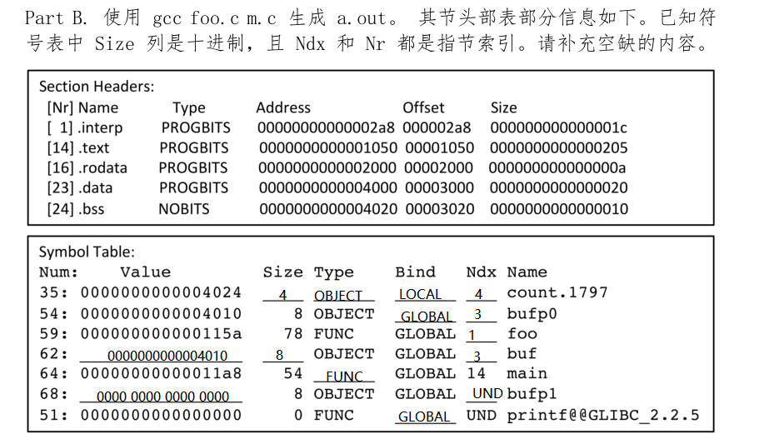



PARTC

/lib64/ld-linux-x86-64.so.2



0 10



PARTD

10 : 8b 15 fa 3f 0 0 mov 0x3ffa (%rip),%edx



0x2004



PARTE

2a: e8 9a 2f 00 00 callq <printf@plt>



3 3



5555555561DE

